A. Cinemas

|  |
| --- |
| BY| CSE21-077 |



|  |  |
| --- | --- |
| Website development On | Analytic Cinemas |

**Website Frame Structure**

**Name of website:** Analytic Cinemas

**Purpose of our site**

Analytic Cinematic website is a platform made to help Its users Get informed about the movies being showcased in the analytic theatres, to its various locations in towns like Gaborone ,Palapye , Maun and Kasane(Not a real theatre btw).

The website has seven pages which contain a.

;

**Home/Index Page**: This is the landing page a user’s sees as our site loads, and we made sure it looks exciting so the user is intrigued to see more.

**Now Showing page:** here is where the user will note and see all the movies currently being showed at the cinemas so they can know what to expect on a specific day.

**Tomorrow page:** Here is where movies to be showcase in heathers are posted giving users to set a reminder to go catch their favourite movie.

**Next-week page**: Same as tomorrow page, this page shows the upcoming movies but on a weekly ahead bases.

**About page**: This page, jus quickly and simply describes our purpose and all about Analytic Theatres, so if users are interested in learning more, about us they can read that page.

**Feedback page**: A successful platform is only due the users suggestion as such I added a feedback page in the site to cater , for the users suggestion to improve functionalities of the site so users feel apart of the process.

**Location page**: Here users can use our embedded maps to get directions to our Biggest Theater in Palapye, as such making it easy to find us even if they are new in town **Site Map of Analytic**

**Analytic Website wireframe**

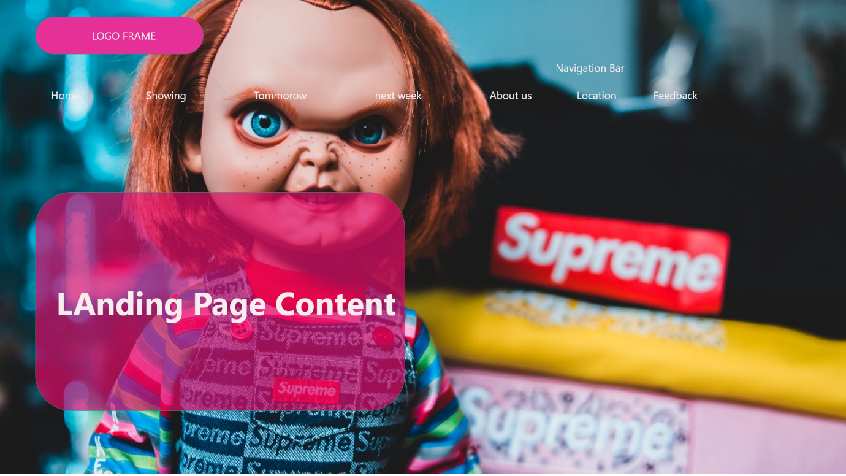

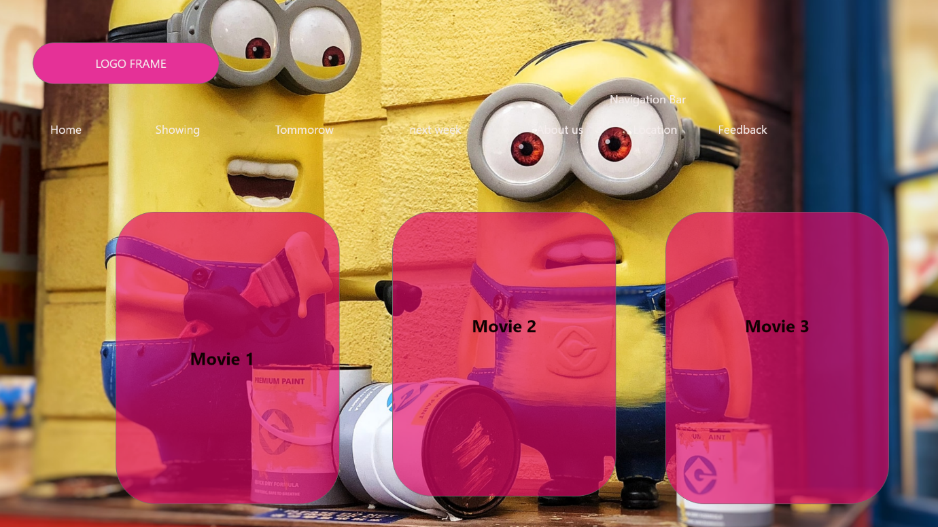

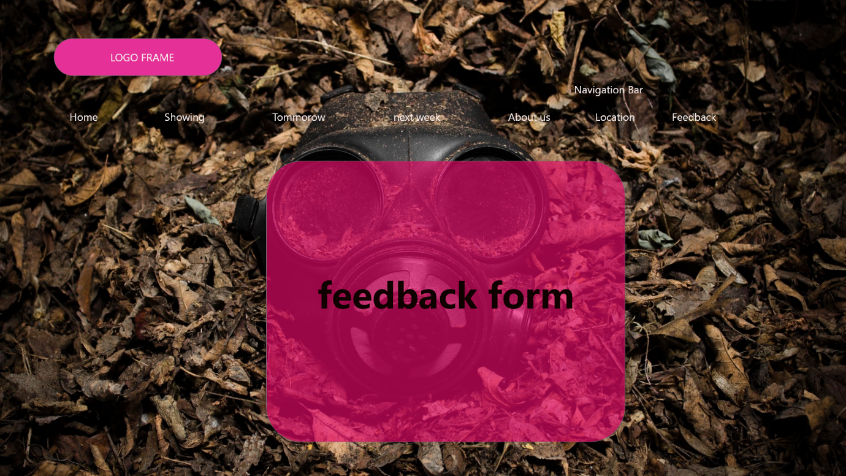

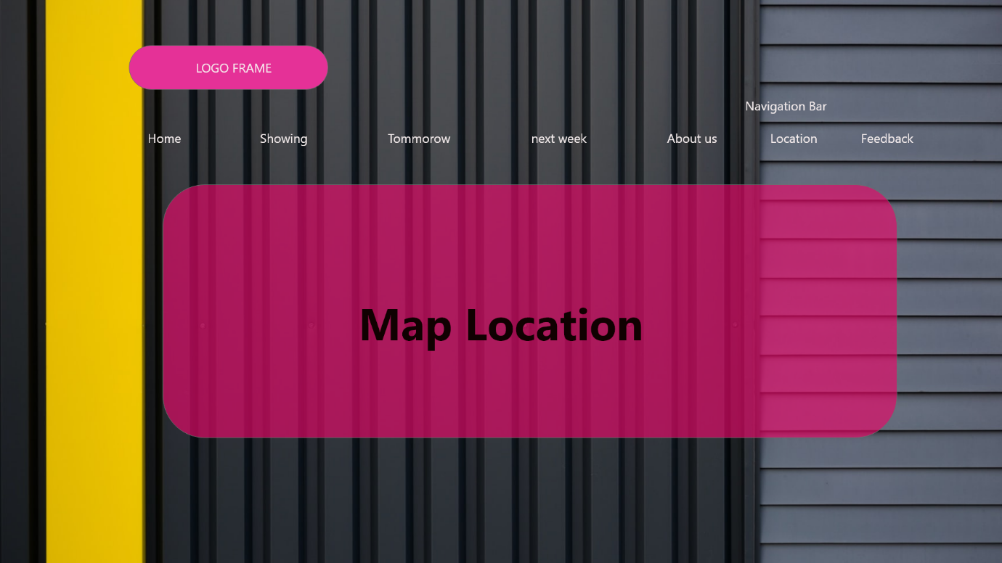

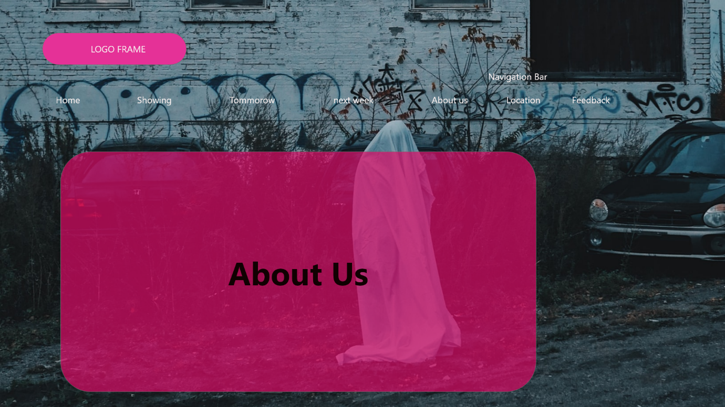

**Note: Images used in the wireframe may differ from The Real- Website**

**Site Structure**

Logo

Simplicity is key, as such we made our logo by not complicating it to present our website as it is too, simple to learn and use. The colors used pink and white are the main feel of the site.



Compact ability

The website was tested in Various Browsers to name a few, Chrome, Mozilla fire fox, Opera, Microsoft edge and Brave browser.

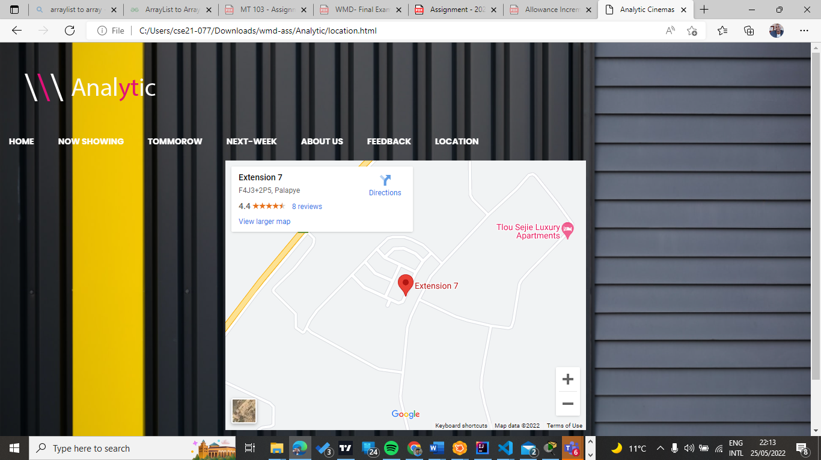

The Audience

This generation is a generation of bingers so, we have a wide variety of users from 10 years olds who enjoy animated movies, to 15 - 26 year old boys who enjoy quality action movies, and our female bingers who, love romantic comedies.

Improvement

This site currently is only read-only as users can only note out the upcoming movies, and currently playing so, id improve the site by adding a book a seat and buy ticket option so users can book tickets ahead.

**Testing**

the site was tested in different screens from phones to tablets to tvs as such it passed the responsive test.

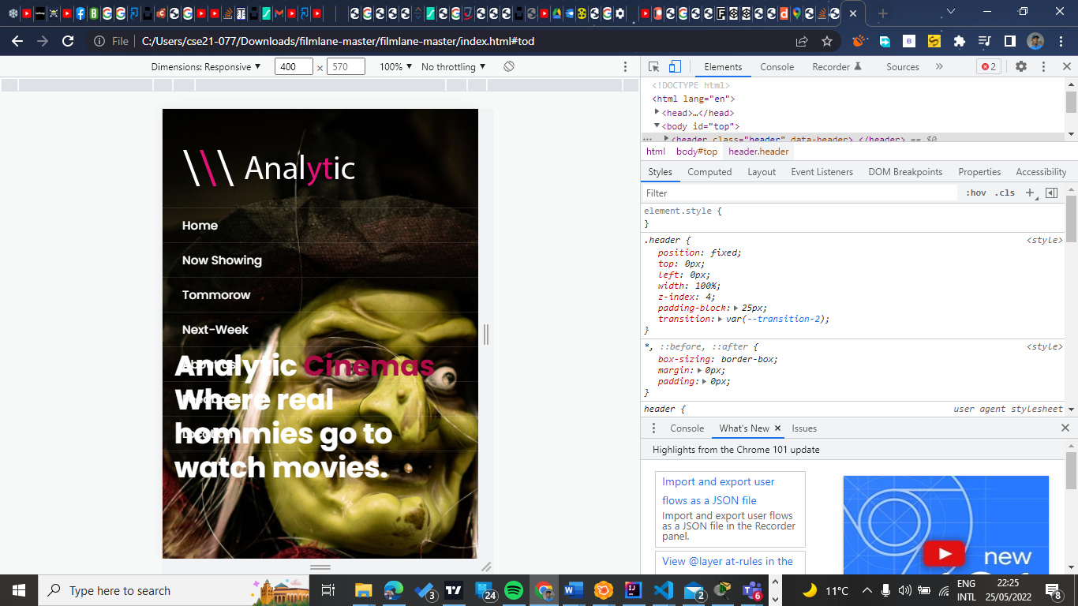

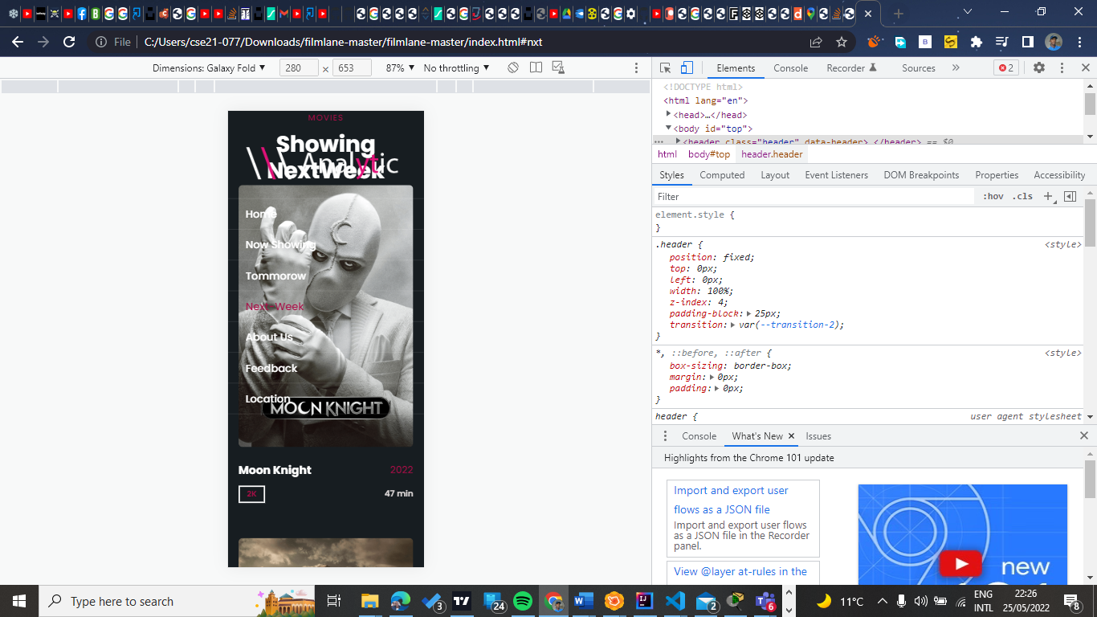

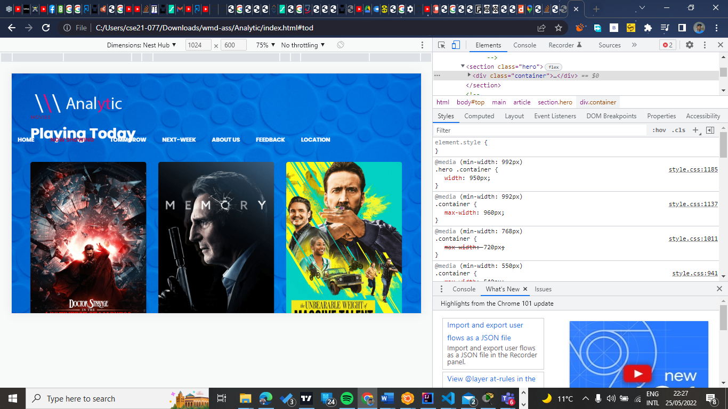

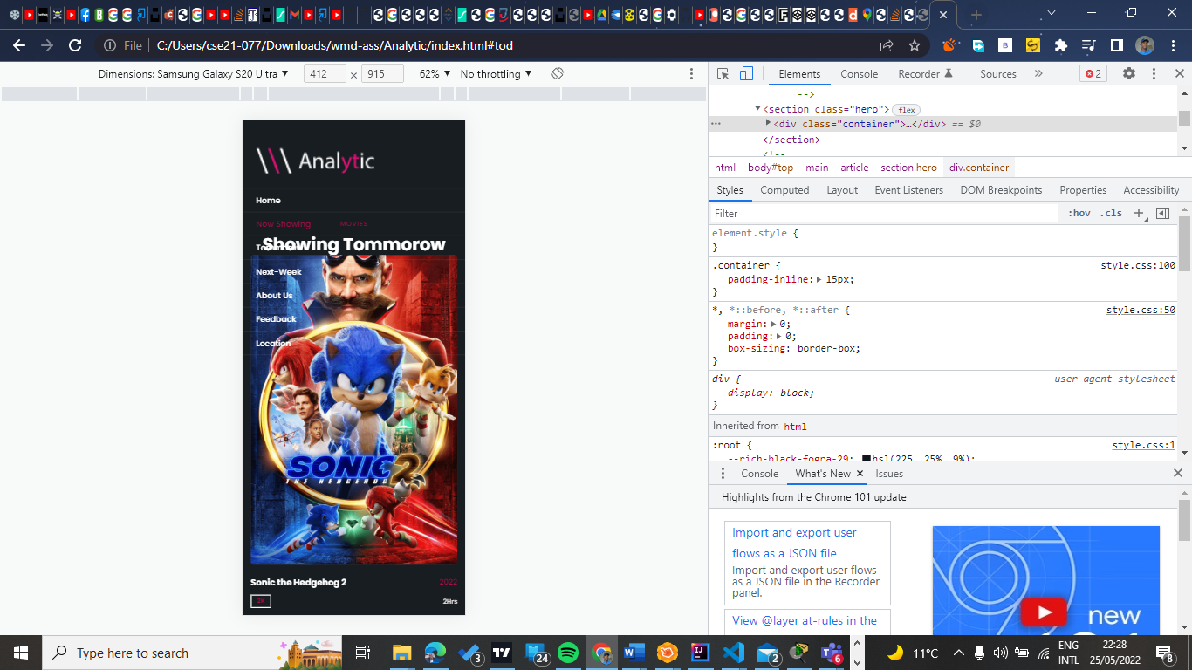

Hosting

* I used GitHub to host the website with the following git io link.

https://cse21-077.github.io/AnalyticCinema/

All in all, our site aims at providing a link between uses and useful content to broaden their entaertainment enthusiasinity, and it was a fun project to build, Thank you.